1. A white background with blue text

   Description automatically generated
2. A screenshot of a computer

   Description automatically generated
3. 
4. 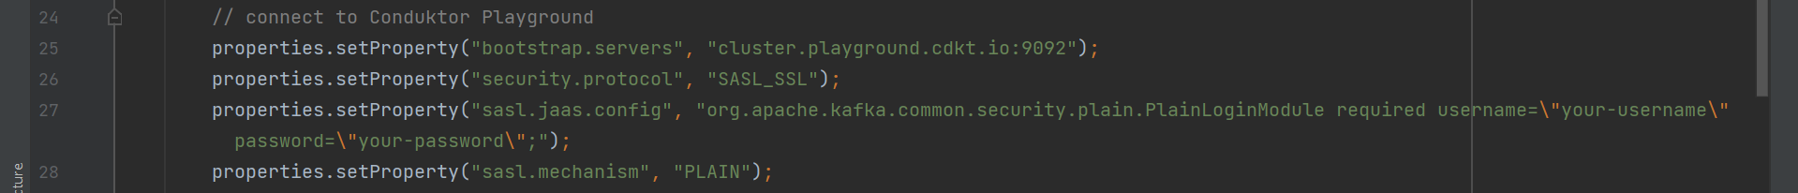
5.   
     
     
     
   